School Implementation Guidelines
Communication
Reviewed: 13/11/2020 Next Review: August 2021

NSW Department of Education Policy, Procedure or Guidelines | This document is to be read in conjunction with the:  - Student Use of Digital Devices and Online Services  - Code of Conduct
School Policy or Procedure (where applicable)
Other Relevant Legislation and Regulation/s

Introduction
Effective communication amongst staff members, community members, parent/carers and students is critical for organisational efficiency and success. Communication protocols help to guide the manner and nature of face to face and electronic communication, as well as identify the best staff member to respond to a query or concern.

Responsibilities
School leaders will:
- Develop School Implementation Guidelines for communication
- Ensure access to translations and interpreters is simple and well-known
- Monitor the effectiveness of communication procedures and refine communication procedures as appropriate
- Lead administrative staff in utilising nominated communication platforms including providing professional learning as appropriate
- Ensure suitable lead time of no less than a week if provided when communicating about school events which represent a variation to normal routine

School teachers will:
- Listen to parents/carers concerns and feedback respectfully
- Adhere to school communication procedures
- Communicate to parents/carers at the commencement of each school year their preferred communication method.
- Nominate within Personalised Learning Plans the preferred method of communication
- Work in partnership with parents/carers with a focus on achieving positive outcomes for all students

Administration staff will:
- Service the reception desk courteously and with a focus on meeting the needs of the customer
- Answer telephone calls politely, directing enquiries as appropriate
- Follow-up queries and provide a timely and effective response
- Adhere to school communication procedures
- Participate in professional learning as appropriate to maintain currency of skill in using nominated communication platforms

Parents and carers will:
- Actively seek information from the school, including by reading the website, parent handbook, newsletter and paper notes
- Download the Sentral Parent Portal and action notifications as appropriate
- Clarify with school personnel when further information is required
- Approach each communication with the school positively, with respect, and with a focus on achieving a suitable shared outcome

Home / School Communication
The school and its staff communicate with parent/carers and the community in a variety of ways. It is the responsibly of parent/carers members to read all communications and act accordingly. The below table demonstrates how the school communicates with parents and community members.

School to Home Method | Purpose & Protocols
Tirriwirri Newsletter | Uploaded to the school website fortnightly with alerts via email distribution list, Sentral Parent Portal and Facebook. The newsletter is the school’s most formal and authoritative publication to the community. It has latest news, reminders, student work samples and updates from the principal, P&C, extra-curricular groups and library.
Email | Email is used sparingly. A newsletter distribution list is kept (subscribe from the link in any newsletter found on the website). Email is also used to send statements account to parents. School email is used where possible and emails are redirected to staff.
Telephone Call | Staff members telephone parents and community members when a discussion is required around a particular matter. It may be related to student learning, behaviour or school events. All calls are logged in Sentral - Data Records – Parent Contact.
Notes Home | Paper notes are sent home sparingly. Excursions, statements of account and invitations to special events may be promoted through paper notes. Parents are asked to check their child’s school bag each day.
Website | The school website acts as a prospectus for the school with a significant amount of static information available to the public including a parent handbook. Newsletters are uploaded to the website. The website contains information that community members can reference regarding procedure. Most notes sent home are also attached to the school website.
See Saw | Seesaw will be used in all classes from K-12. The content of students’ work and frequency of posting will depend on year level and curriculum. With collaboration and consistency across year levels designated pieces of work will be published at least once a week. Seesaw will be used to publish items of the following nature to parents:  - work samples  - collaborative group activities  - audio, video and photos of students both at work and of their work
Text Message | The school only communicates with parents via text message to notify of student absences. Text messages are sent each day between 9:40 am and 10:00 am. Parents have the facility to reply to the text message to provide an explanation for their child’s absence.

It is acknowledged that parents and community members often seek to initiate contact with the school. The below table demonstrates appropriate methods for making contact with key personnel. This information should be read in conjunction with the communication flow chart in the appendix at the back of this document.

Home to School Method | Purpose & Protocols
Note | Parents may send written notes to school for many purposes including but not limited to:  - Explanation of student absence  - Feedback on a program or initiative  - General communication to class teacher about student wellbeing concerns  Notes should be sealed in an envelope addressed to the intended recipient.
Email | Emails should be sent to the general school email address tirriwirri-s.school@det.nsw.edu.au particularly when matters are of an administrative nature. In instances where teachers have distributed their email address and they have expressly endorsed the use of email, parents should communicate respectfully and courteously. Expected response time varies. Teachers are not expected to respond to emails outside of normal work hours of 9:00am – 5:00pm, nor are they encouraged to email during times when they are working with students during the school day. The school’s guideline for email response is 3-5 business days. The principal can be contacted directly at gabrielle.sheather@det.nsw.edu.au however the communication flow chart at the back of this document should be observed. In most cases, the best person to address an issue or concern is not the principal.
Telephone Call | Where matters require a back and forth discussion, the use of telephone or face to face meeting is recommended. Parents may call the administration office during hours of 8:30am – 3:30 pm. Office staff can take messages and pass them onto relevant staff members, or if the staff member is available can connect the call accordingly. Messages are to be forwarded to staff via Teams and/or a phone call to their classroom depending on the urgency of the message. For changes to routine such as amendments to after-school plans, the office will notify the student’s teacher who will in turn pass the message on. Telephone interpreters can be arranged for most languages at a moment’s notice. Parents are encouraged to use this service.
See Saw | Parents are able to comment or send messages to staff through the app. Staff are only required to message back between the hours of 8:30am – 5:00 pm.
Text Message | Text messaging is only appropriate when in response to a message from the school notifying of a student’s absence.
Meeting | Where matters require a back and forth discussion, the use of telephone or face to face meeting is recommended. Engaging in a meeting with the class teacher, executive staff member or principal can be an extremely productive activity, allowing viewpoints to be heard and consensus reached. Meetings must at all times be conducted in a positive spirit with the best interests of students at the core of all interactions. Interpreters can be arranged for most languages with sufficient notice.

School Community Charter
The School Community Charter outlines the responsibilities of parents, carers, educators and school staff in NSW public schools to ensure our learning environments are collaborative, supportive and cohesive. Parents/carers are asked to read the School Community Charter to ensure they understand how important it is to create a positive learning environment for our students. The Charter is appended to this document

Staff Members Communicating With Students
Positive and respectful communication between staff members and students is an important component of an effective wellbeing program. Tirriwirri School staff members prioritise communication with students which seeks to raise personal responsibility and to develop trusting relationships which underpin engaged learning. Working With Children Check procedures and the Code of Conduct must be considered when communicating with students.

In supporting effective communication, the following roles and responsibilities have been agreed between school leaders, the school’s NSW Teachers Federation representative and the Parents and Citizens Association

Responsibilities
School leaders will:
- Model effective communication with students
- Provide staff with professional learning and resources that will meet the individual communication needs of students
- Lead effective English as an Additional Language or Dialect programs to ensure students with growing proficiency in English are supported in their communication needs
- Provide professional learning for staff members to support productive and respectful communication with students
- Comply with Working With Children procedures

School teachers will:
- Prioritise polite, friendly, warm and caring interactions that signal an investment in a student’s wellbeing
- Listen to students, seeking first to understand and then to be understood
- Apply procedural fairness including a right to be heard and to respond
- Use strategies that are appropriate for individual student communication needs

Students will:
- Develop understandings that they are responsible for their behavioural and learning choices
- Listen to teachers, showing respect and courtesy
- Engage using appropriate communication systems
- Engage in discussion when issues arise that is focused on positive future behavioural choices

Internal Staff Communication
Staff members use a range of mechanisms to communicate about organisational and operational facets of the school. At all times, communication must be professional and purposeful in line with the Code of Conduct and Dignity and Respect in the Workplace Charter.
Communication Method | Purpose & Protocols
Email | Messages from one staff member to another or to a group of staff members which contain organisational details, reminders, or dissemination of information pertinent to the profession.
Sentral | Weekly events schedule summarising information contained with the Sentral calendar. General reminders are also listed related to administrative tasks which may be due at the time (e.g. reminding about PDP dates, report comments).
Microsoft Teams | Depository for timetables, rosters, roles/responsibilities, Performance & Development Plans and other organisational information which staff members may need to access remotely.
Public Announcement System | Used for emergency evacuation and lockdown, and urgent messages relevant to the whole school. Used outside learning time to remind staff members of meetings. Used as a last resort to locate a student required to leave school early, after telephone call to the classroom and walk to the room fails to locate student.
Internal Telephone Calls | Used for interactions between staff members. Teachers must only use this platform sparingly when teaching face to face. It is appropriate for quick fact-checking, messages and to seek support from colleagues when managing a challenging situation.
Pigeon Hole | Used to deposit hard-copy notices and correspondence between staff members. Staff members must check their pigeon hole daily.
Sentral Calendar | Every school event must be added to the school calendar within Sentral. Administration staff have editing rights, meaning that they are able to add events to the calendar. If staff want to add an event to the calendar, they must provide the following information to Administration staff in a timely manner.  WHAT:  WHEN:  WHERE:  WHY:  COORDINATING STAFF MEMBER:  INFORMATION NOTE ATTACHED: YES/NO  Placeholder events may be added with “more information to come closer to the date” and the name of the coordinating staff member.  The administration office is able to publish information/permission notes on the school website and link the note to the calendar event.

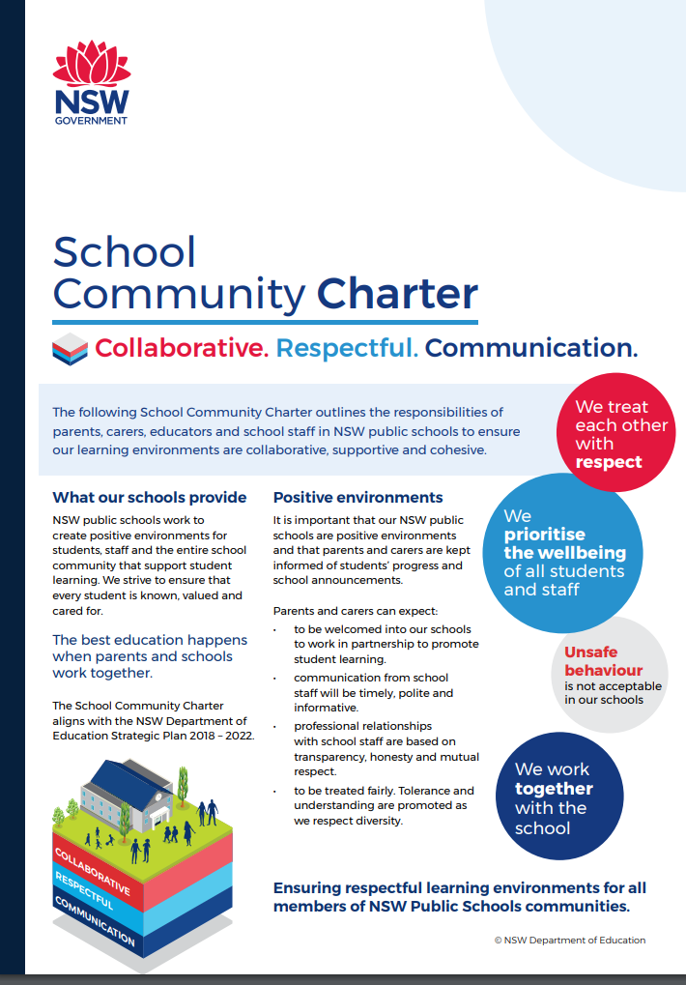

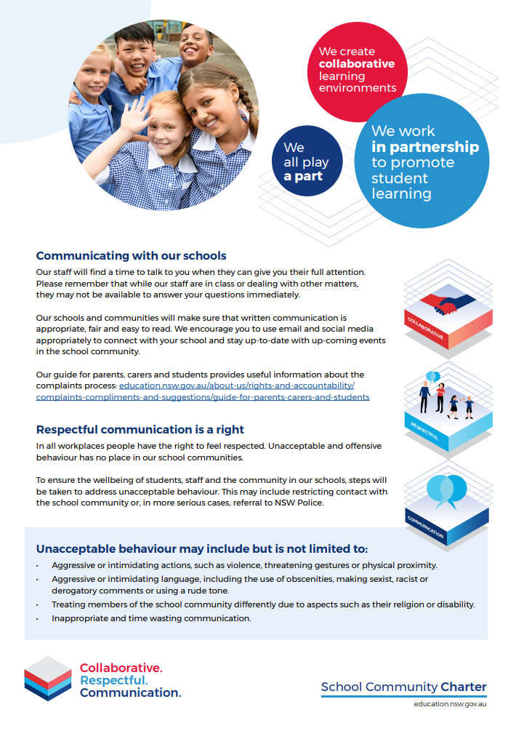
Communication Flow Chart

To receive the most effective and timely response to a query, parents are asked to use the following chart when directing their communication within the school. The flowchart only progresses to the next level if the issue or concern is not satisfactorily resolved.

Step 1: | Academic | Social/Emotional |  |  | Behavioural |  |  | Administrative
Step 2: | Classroom Teacher |  |  |  |  |  |  | School Administration Team
Step 3: | Assistant Principal (Grade Supervisor) |  |  | Learning and Support Team |  |  | School Counsellor
Step 4: | Principal
Step 5: | School Services

Seeking Support Flow Chart
- Identify what I need.
- Identify who I need to speak to about it?

Principal | Assistant Principal | SAM or Business Manager | SAO
- Mandatory Reporting  - Emergency support after an ambulance is called.  - Critical incident, if an AP is not reachable.  - Leave matters  - Calendar for Sentral | - Student matters  - Staffing matters  - Parent matters  - Ordering of resources  - Ordering updates  - Rostering  - PDP and professional learning for teaching staff  - Excursions | - Pay matters  - SLSO information, including attendance and rostering  - Facebook  - School Website  - Phone messages | - Student and SLSO attendance  - Phone messages
- Seek support.

- It is the responsibility of the support staff member to respond to the request in a timely manner (within 3 business days).

